Trench, Brian
NSW Department of Education
Eco-Snapshot
SCHOOL ENVIRONMENTAL AUDIT data collection templates
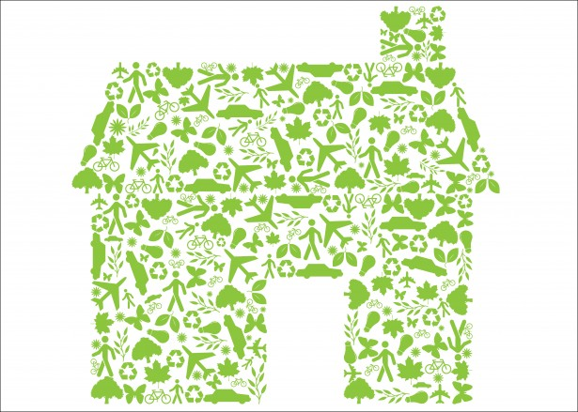

Area of the school being surveyed (Block):____________________________________

Item | Number of appliances in your block? | TOTAL | Estimated  hours  per day  (change if necessary) | Days per year  (Weeks per year  x  days per week)
inside lights (include corridors)  fluorescent |  |  | 6 | 40x5=200
outside lights  (include corridors)  Fluorescent |  |  | 12 | 52x7=365
Floodlights |  |  | 12 | 52x7=365
ceiling fans |  |  | 5 | 12x5=60
air conditioners |  |  | 6 | 20x5=100
heaters (electric) |  |  | 4 | 20x5=100
computers |  |  | 3 | 40x5=200
printers |  |  | 3 | 40x5=200
photocopiers |  |  | 6 | 40x5=200
overhead projector |  |  | 1 | 25x5=125
refrigerators |  |  | 24 | 52x7=365
freezers |  |  | 24 | 52x7=365
hot water units |  |  | 24 | 52x7=365
boiling water unit-zip |  |  | 24 | 52x7=365
TV |  |  | 1.5 | 10x5=50
video |  |  | 1.5 | 10x5=50
microwave oven |  |  | 0.5 | 40x5=200
stove top |  |  | 1 | 40x5=200
oven |  |  | 1 | 40x5=200
radios |  |  | 0.5 | 10x5=50
jug/kettle |  |  | 2 | 40x5=200
pottery kiln |  |  | 5 | 10x1=10
IWB

